*This mod must be used with the TerraFirmaCraft mod for Minecraft.*

## Introduction

The idea behind this mod came from a forum reply on my other mods. One of the forum members mentioned how hard it was to find certain minerals, as well as the ores I had previously wrote about and fixed with my other mods.

This forum member indicated that salt was hard to find in their world due to not being able to find Rock Salt. They suggested that if I replace the sulphuric acid in the anodising vessel with salt water I could use the same process the extract the salt from the salt water.

After careful consideration and talking it over with another TFC player I play with a lot, it was decided that a new device would be required to perform this task.

And so the Evaporator Pan was created. The idea behind it was to make it viable around the same time the player starts to use ores in TFC, namely copper. Copper is quite a common ore and so it was used as the metal to construct the Evaporator Pan.

An anvil plan was also decided upon as the pan was a more complex object to construct than a simple ceramic mold could produce.

## Items

1. Evaporator Pan – a pan that is used to extract minerals from certain fluids.
2. Ceramic Bucket – a bucket made with fire clay that can be used to carry Fresh, Salt and Hot Spring water.

## Recipes

### Evaporator Pan

To create the evaporator pan using an anvil plan, place two workable copper sheets in the anvil slots and click the plan button. Select the evaporator pan plan from the list.



Then by using the anvil buttons, create the evaporator pan. You will get one evaporator pan.

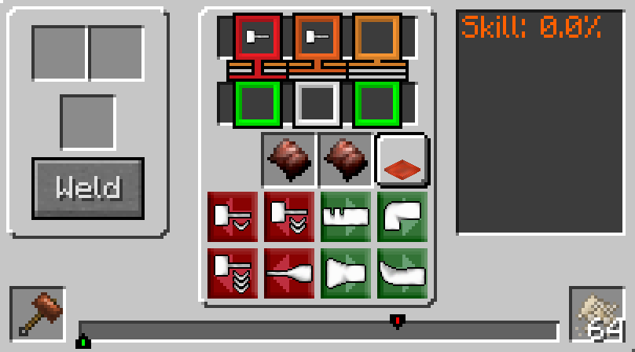

This is the evaporator pan after being completed in the anvil.

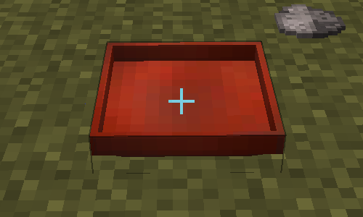

### Ceramic Bucket

To create the ceramic bucket, use fire clay and the follow knapping recipe.

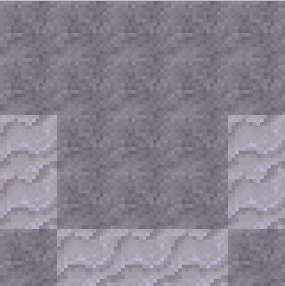 

## Process

Before the process can be started, the right conditions must be met. As this is an evaporation pan, it uses the sun and the temperature to determine if the evaporation process can start.

The evaporation pan must adhere to these conditions in order for the process to start:

1. It must be daylight (between 6am and 6pm).
2. It must have clear access to the sky (nothing must cover it). You can cover it with glass or other transparent blocks as this does not prevent access to the sky.
3. The current temperature must be above the temperature in the config file (default 30).

If all these conditions are met, then the evaporation process can start.

### Starting the Process

If all the conditions above are met, then when a fluid is added to the evaporator pan, the process will start. While the process is running, particle clouds will appear from the pan (as seen in the image).

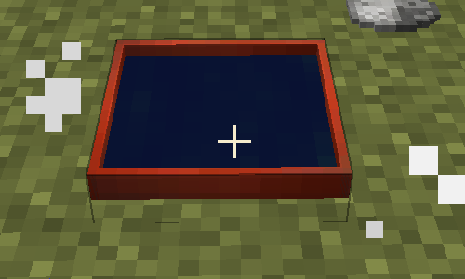

While the process is running, additional fluids can be added to keep the process running. When all the fluid evaporates the process will stop. If any of the evaporation conditions change (eg. it turns to night) the process will stop.

When the player right-clicks the evaporator pan, the Gui is opened. If the player right-clicks with an empty hand and while sneaking, the player will grab any extracted items, without the need to open the Gui.

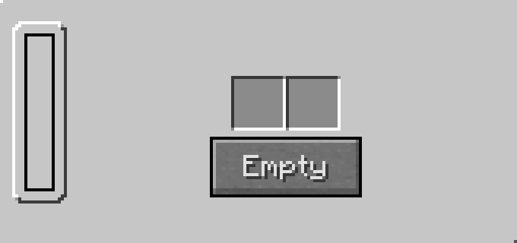

This image shows the evaporator pan completely empty.

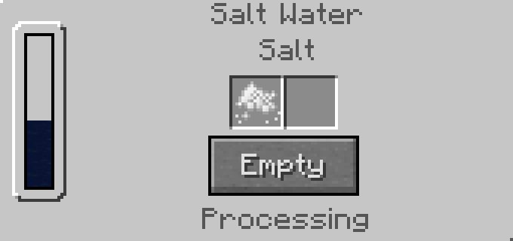

This image shows the evaporator pan with Saltwater and processing.

Any items extracted from the fluid are stored in one of the two output slots ready for collection. **If all the output slots are filled and the evaporation process is still running, any additional items extracted from the fluid are spawned into the world instead.**

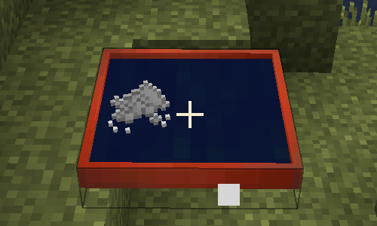

This image shows the evaporator pan filled with Saltwater and Salt waiting to be collected.

## Additional Information

1. Evaporation pans can be stored in chests.
2. Evaporation Pans are **not** stackable.
3. When the player harvests the evaporation pan from the ground, all the fluid is drained and the extracted items are spawned into the world.
4. Items extracted from the fluid are shown hovering above the pan. If the player right-clicks the pan while sneaking, the items are transferred into the players hand. Your hand must be empty.
5. Config options have been included so that the player can alter certain aspects of the process. The options are:
   1. evaporationDelay- Set this value to the number of ticks between each evaporation process attempt.
   2. evaporationTemperature - Set this value to the temperature in which fluids exposed to the sun start evaporating.
   3. enableHotSpringWater - Set this to true to allow the evaporation of Hot Spring Water.
6. If you fill the evaporator pan with a fluid that does not have a recipe, the fluid will still evaporate, but nothing with be extracted.
7. Items extracted from the fluid that are not able to be stored in one of the output slots will be spawned into the world.
8. A ceramic bucket was added that can be used to carry Fresh, Salt and Hot Spring water.

The evaporation pan uses recipes to extract minerals from fluids. An EvaporatorPanManager was created to store the recipes used by the evaporator pan. This allows the pan’s functionality to be extended in the future, if needed.

Currently four recipes have been created:

1. Extract Salt from Saltwater.
2. Extract Sulfur from Sulfuric Acid.
3. Extract Saltpeter from Nitric Acid.
4. Extract Fertilizer from Hot Spring Water.

Multiple recipes cannot be created that use the same fluid. Only one recipe per fluid.